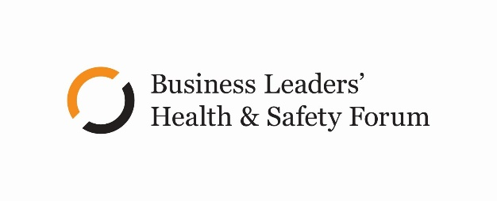

LEADERSHIP STATEMENT

Workplace COVID-19 Vaccinations

Mandating our strongest control to protect health & wellbeing

26 October 2021

Context
The COVID-19 pandemic represents an unprecedented threat to how we work and live. This is evidenced by the Government’s Public Health Orders demanding national and regional lockdowns, closed borders, and the significant restrictions of personal, business and societal freedoms.
The advent of the more transmissible Delta variant has severely limited the effectiveness of these restrictive protections, making elimination all but impossible.
International experience and the NZ Government’s advice underline that a safe return to near normal will require high vaccination rates.
While Public Health Orders have mandated vaccinations for workers in MIQ, border facing roles, and more recently, healthcare and educational settings, and any business where vaccination certificates are required by customers, other businesses have no such legislative air cover for mandatory vaccination.
We acknowledge that there are a range of complex obligations to navigate including health and safety, employment relations, privacy and human rights. In a global pandemic, our view is that a strong health response requires the support of a strong business approach.

Mandating for today and tomorrow
The Forum’s leadership position is that vaccinations are the most effective control to protecting people’s health and therefore can be mandated for any workers’ roles. This position recognises:
- the unprecedented and serious threat to the health, safety and wellbeing of all New Zealanders, including our most vulnerable people
- the Government’s evolving position on mandating
- the Forum’s commitment to growing cultures where people and business can thrive
- COVID-19 is here to stay, and so too should the protection from this significant health and safety risk to all our people while at work.
This is a leadership position, not a legal opinion. It has been developed with input from a range of expert opinions, but ultimately business leaders and Boards need to exercise judgement and make their own decision.
This decision should be centred on the health and safety of people and the duty of care at work.

The approach
This leadership position to mandate workplace vaccinations is based on four planks. It is:
- Principle-led with people’s health and safety at the centre
- Specific risk-based assessment
- Developed in good faith
- Part of other comprehensive COVID-19 controls.

People’s health and safety
The duty of care for workers’ health and safety is our primary focus.

Risk-based
On a risk basis, this position advocates for the ability to mandate vaccines across all workplace roles because:
- the likelihood of exposure to the Delta variant now or in the near future is high, if not inevitable.
- the consequences of infection are potentially significant.
- vaccinations are the best control available to minimise the risks in the workplace
- vaccinations are deemed reasonably practicable.

Good faith
Our position also considers the duty of good faith. In this context, as part of the duty of good faith, employers need to consider:

- How they engage and consult with their people
- What they do to support their people (education, employee sentiment survey, information, the position on time-off work to attend vaccination appointments, etc.)
- The privacy of their employee’s data
- How they will manage exceptions and treat those who decline to be vaccinated or decline to provide information about their vaccine status (permanently working from home, potential re-deployment, dismissal, etc.)

Comprehensive controls
We accept there are other controls, in addition to vaccinations, which can be used in parallel to mitigate the risks of Delta, which can include:

- PPE
- Testing
- Self-isolation
- Working from Home
- Workplace redesign and improved ventilation options
- Scanning using contact tracing wearables or apps, and using the NZ COVID Tracer app

The Forum’s leadership position is that vaccinations are the most complete and robust control we have today.

Taking action
We suggest businesses need to undertake several steps. These include:
- Undertake a risk assessment, which may capture specific roles, groups of similar roles or your workplace as a whole. This risk assessment should be informed by the latest guidance from WorkSafe and any legislated process. This risk assessment should also evaluate risk factors and controls, and should be consulted on with your people and their representatives before it is finalised.
- Consider how you will manage exceptions. We believe this will be an area of public policy development that will continue to become clearer over the coming weeks. Regardless of this, we suggest you consider the current employment law requirements and the findings of the employment relations cases to date.
- Develop a position and draft a policy on vaccinations that would apply to your organisation (see Forum Policy Guidance and Policy Builder) and consult on it with your people and their representatives.
- Ensure the final policy is monitored and updated regularly to reflect developments – including new or changed controls and ways to produce evidence of vaccination).

